**Natus Vincere Project Proposal: NearChat**

Members: Victor Du, Jacob Kelleran, Clyde Koh

Project Objective: NearChat is a concept mobile app which lets users pick unique interests, and the app will match them with people w/ shared interests nearby to chat with.

Project Deliverables:

* JSON REST API server (Apache Tomcat-based)
* SQLite3 database for API server data storage (login username + password hashes, latitude/longitude of users and user messages, UUID authentication tokens)
* API server documentation
* Android application client

Deliverable Schedules:

* 3/30/21: Documentation for API server commands finished
* 5/12/21: API server prototype + SQLite3 database is finished and fully functional
* 5/30/21: Android application prototype is finished and functional
* 6/10/21: Android application is tested and free of most bugs

Project Roles:

Clyde: Android app developer, app QA tester​

Jacob: API server developer, Android app developer​

Victor: API server developer, Android app developer, API server documentation writer​

Expected Challenges:

* Not all group members are familiar with Apache Tomcat. Group members will need to be instructed on setting up their Tomcat development environment. (installing Tomcat runtime and Eclipse WTP (Web Tools Platform) environment for deploying Eclipse projects to Tomcat server)
* Not all group members are familiar with Android development. Group members will need to be instructed on how general MVC works, how to script the Android MVC, and how to create Android View XMLs using the Android Studio drag-and-drop view editor if unfamiliar.
* Not all group members are familiar with the REST standard. Group members will need to be instructed on REST standard if unfamiliar.
* Not all group members are familiar with SQL language. Group members will need to be instructed on SQL if unfamiliar.

User Scenarios:

1. Andrew is a freshman to an out-of-state college and is looking for friends interested in mountain biking. He opens the NearChat app and searches for people nearby with a shared interest in mountain biking. The app gives Andrew a list of individuals interested in mountain biking with others and lets Andrew chat with them over the app Telegram.
2. Naomi is a freshman to an out-of-state college and is looking for friends interested in drone photography. He opens the NearChat app and searches for people nearby with a shared interest in drone photography. The app gives Naomi a list of individuals interested in drone photography with others and lets Naomi chat with them over the app Telegram.

Non-functional requirements:

* App should support Android version 4.3+ for maximum audience (>95% Android phones in 2021)
* Exact locations will not be given from the server to the NearChat app client.

Functional requirements:

* Server will tell the client the general distance it is away from other interested individuals.
* App should be integrated with the Telegram chat app.
* App should use phone GPS chip to get coordinates to send to server so it can search.

Technical Summary:

Techniques used in implementation and testing: We will test code on sample data within specifications and see if it behaves according to specification in our JavaDoc

Challenges and how we resolved them: We don’t all know SQL and JSON so we learned SQL language and JSON notation using W3Schools and StackOverflow

What we’ve learned: we learned SQL language and JSON notation using W3Schools and StackOverflow

Resources we found helpful: W3Schools and StackOverflow

Code Review:

NearChat API Server Source Code:

APIServlet.java

Program Specifications: Excellent

Readability: Excellent

Code Efficiency: Excellent

Documentation: Developing

Assignment Specifications: Excellent

SQLUtils.java

Program Specifications: Excellent

Readability: Excellent

Code Efficiency: Excellent

Documentation: Developing

Assignment Specifications: Excellent

Nearchat Android client:

Program Specifications: Excellent

Readability: Excellent

Code Efficiency: Excellent

Documentation: Developing

Assignment Specifications: Excellent

Design/ Architecture diagram(s), and introductions, descriptions , explanations for your diagrams:

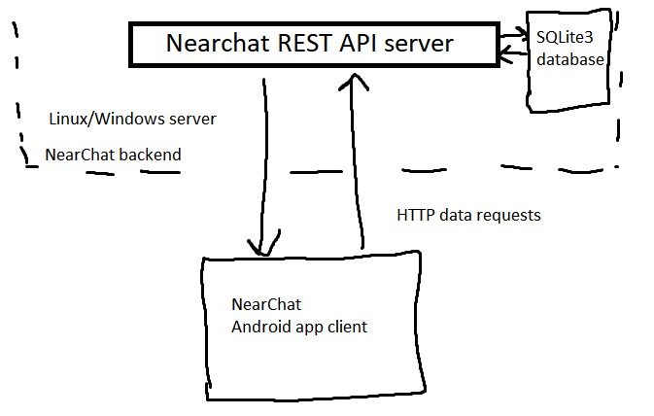

The NearChat Android app will use HTTP requests to communicate with a RESTful API server based on Apache Tomcat. This API server stores authentication and user profile data on a SQLite3 database. After the user logs into the app, the server sends the client an API key which will be stored locally and used subsequently for all transactions. When the user makes a request to the server to search for people near them, the server searches the SQLite3 database for people within the search radius of the user (using the Haversine theorem given the user’s coordinates and coordinates of other users) with similar interests, and gives the app a JSON array of JSON objects representing each person, which the app will display graphically.

Discuss design decisions, concerns, assumptions, limitations etc:

* App will need to have user privacy in mind, so exact locations of other users can’t be shared.
* Users who are not interested in searching for friends should be able to make their profile invisible from searches.

Resources:

* StackExchange
* GeeksForGeeks
* Other GitHub projects
* W3Schools
* Google the problem!!

Tooling Assessment:

UI Tools: Eclipse (for server development), Android Studio (for app development)

Server Hosting: Google Cloud Platform or other cloud hosting service

Database software: SQLite3 (both serverside + clientside)

Programming Languages: Java